# *INTRODUCTION*

* 1. ***Overview***

*Retail management is the process of running and managing retail day-to-day activities surrounding the selling of goods and services to customers. Preparing and controlling the stores budget aiming for minimum expenditure and efficiency.*

* 1. ***Purpose***
* *Motivating employee*
* *Growing store traffic*
* *Meeting sales goal*
* *Improving profitability*
* *Ensuring customer satisfaction*

1. ***Problem Definition & Design Thinking***
   1. ***Empathy Map***

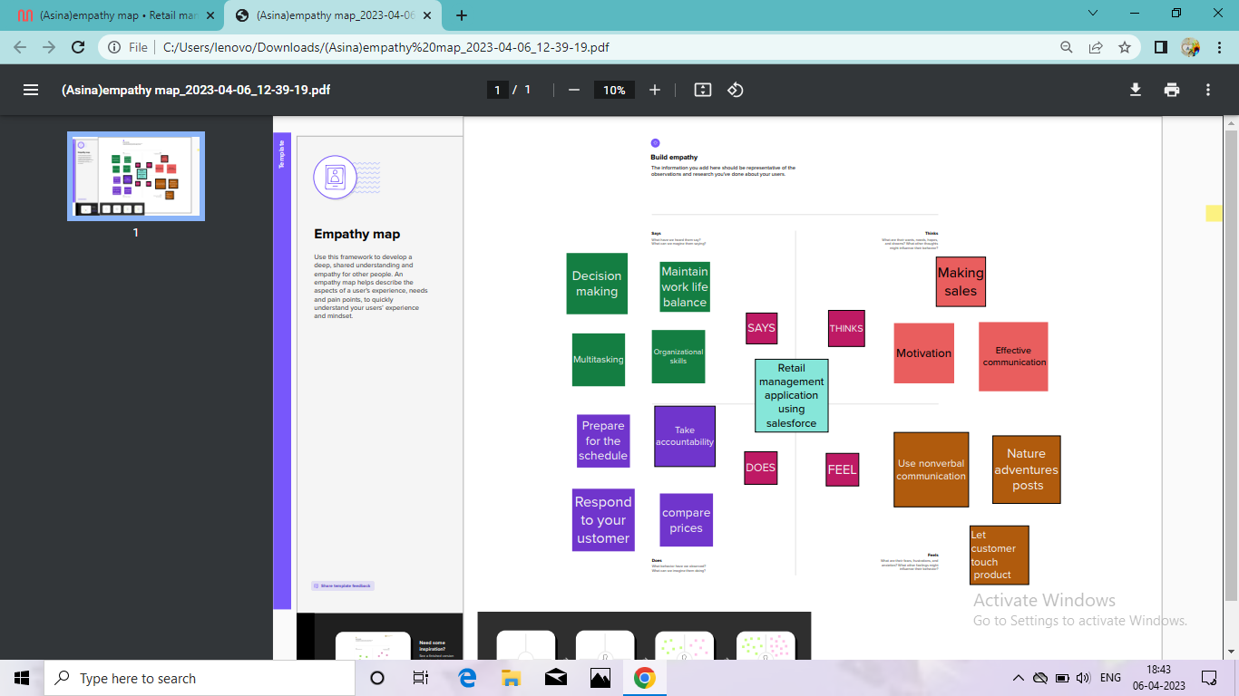

* 1. ***Ideation & Brainstorming Map***

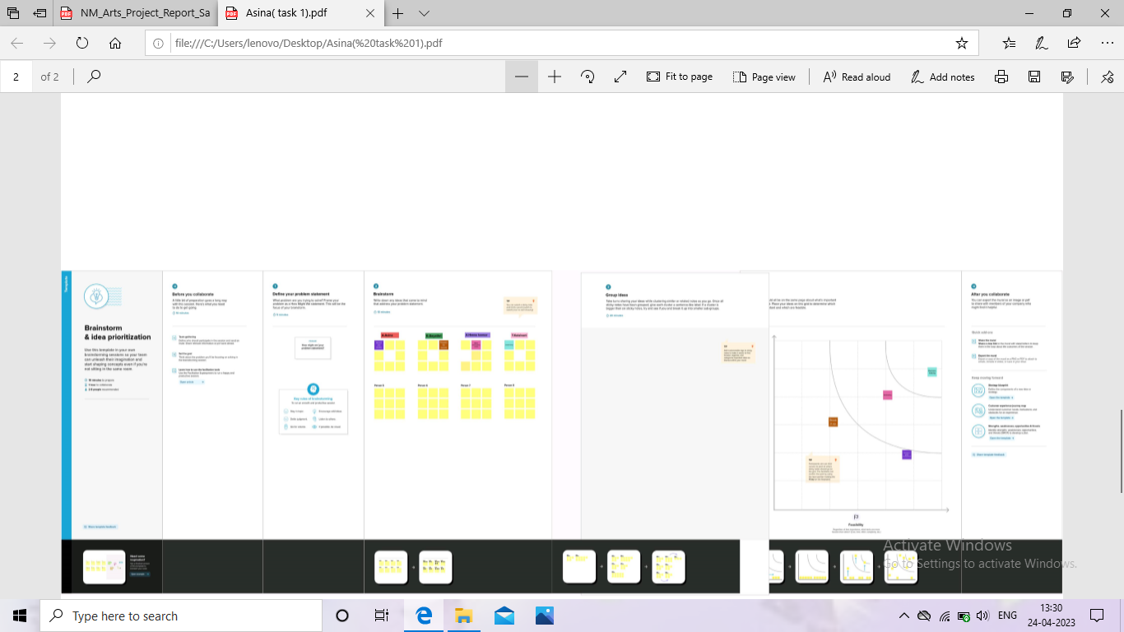

# *RESULT*

* 1. ***Data Model***

|  |  |
| --- | --- |
| ***Object name*** | ***Fields in the Object*** |
| ***obj1*** | |  |  | | --- | --- | | ***Field label*** | ***Data type*** | | *Dispatched* | *Checkbox* | | *Tracking Id* | *Checkbox* | |
| ***obj2*** | |  |  | | --- | --- | | ***Field label*** | ***Data type*** | | *Contact* | *Formula* | | *Dispatch/tracking* | *Master detail relationship* | |

# *Activity & Screenshot*

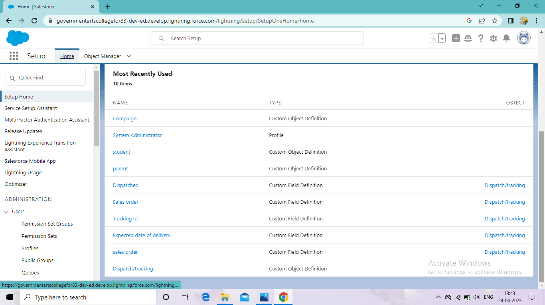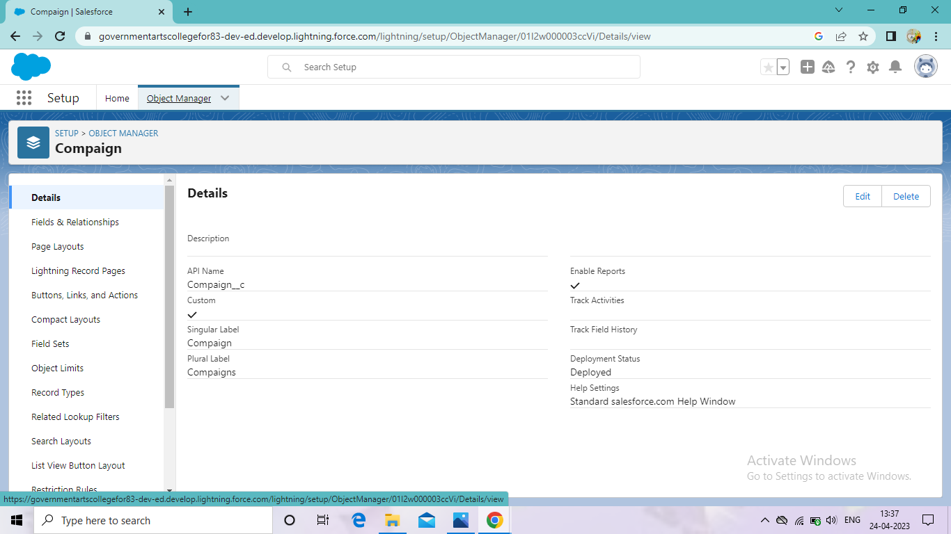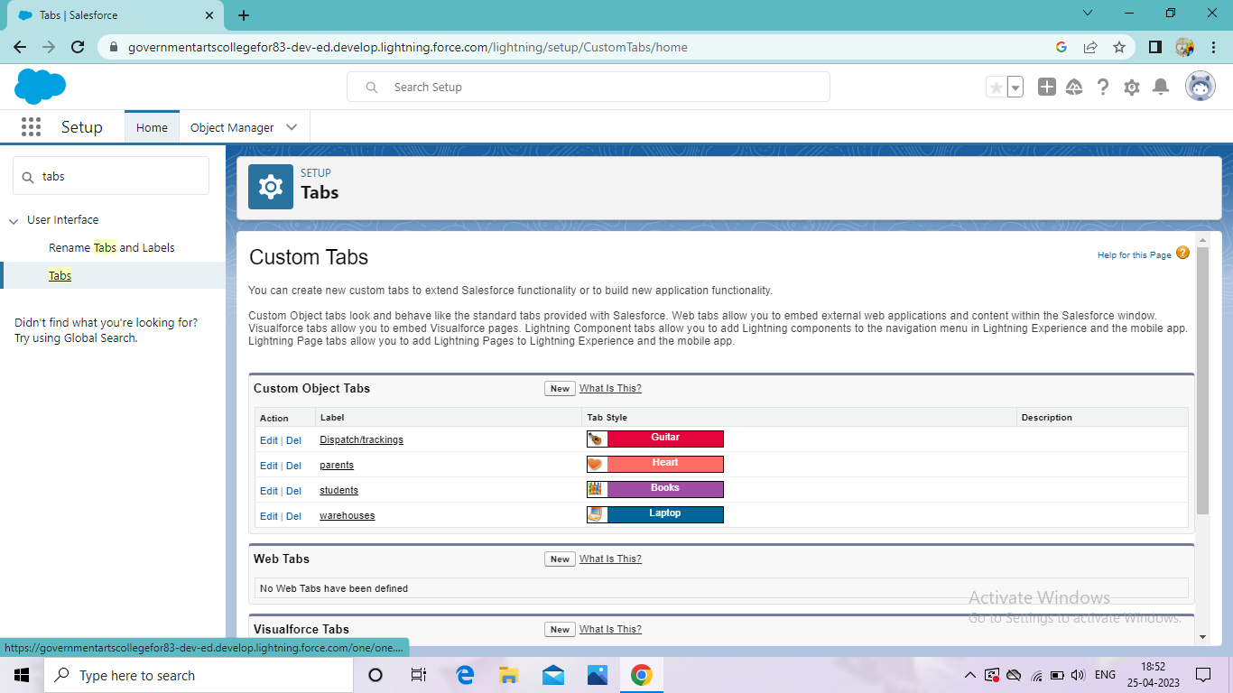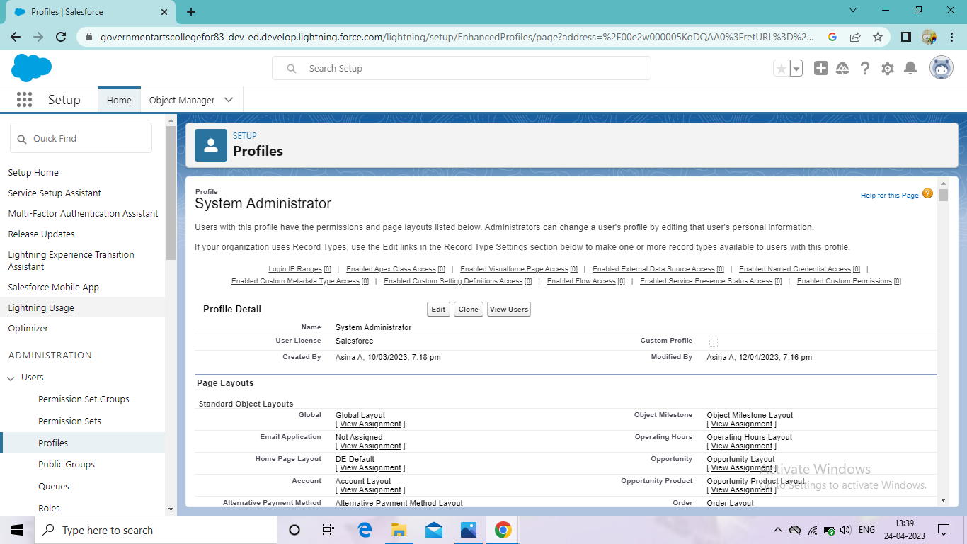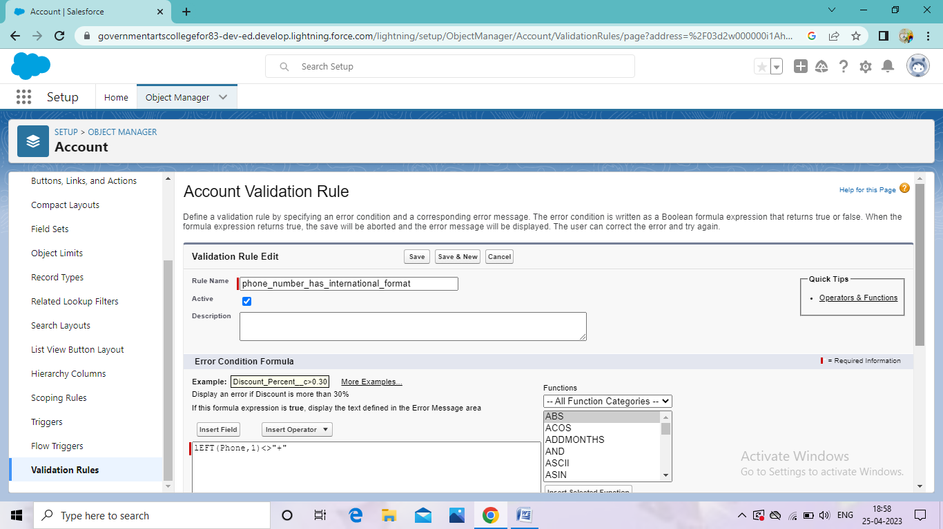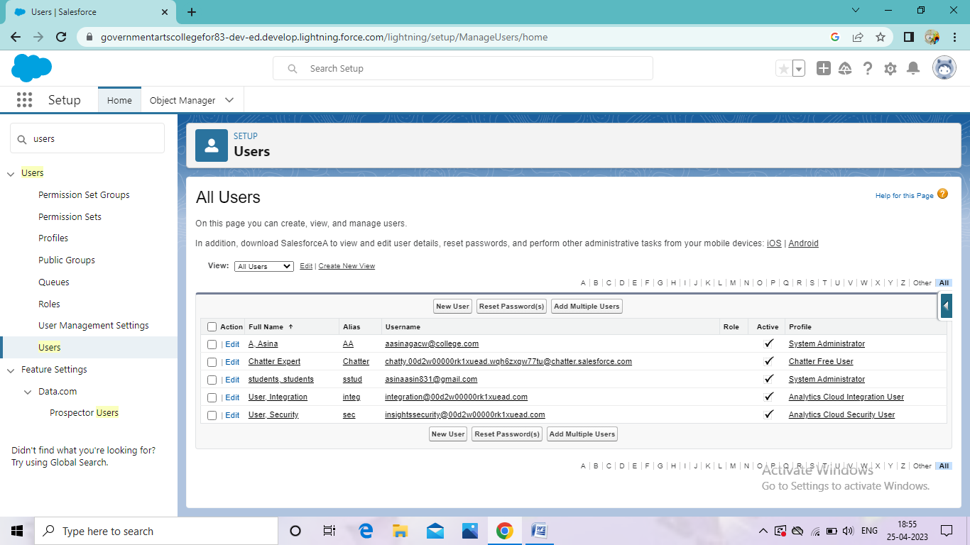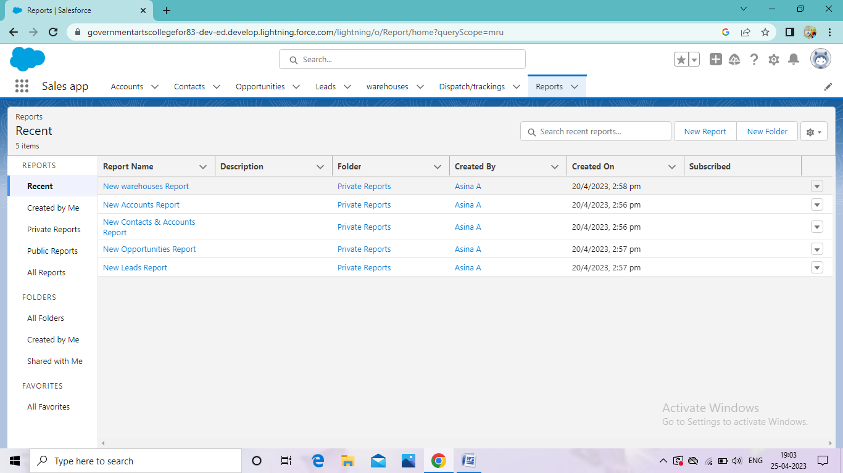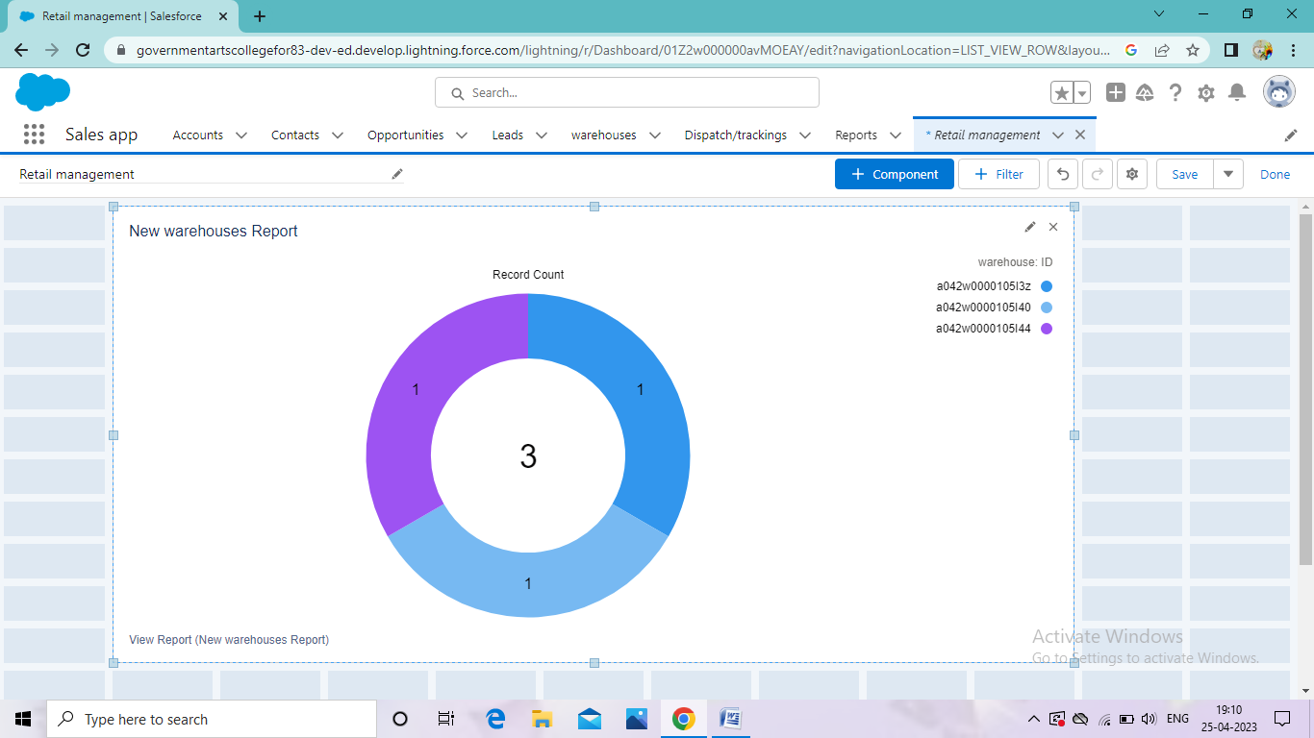

# *Trailhead Profile Public URL*

*Team leader- https://trailblazer.me/id/asina18*

Teammem1-https://trailblazer.me/id/ttkalaivani

Teammem2-https://trailblazer.me/id/heena85

Teammem3https://trailblazer.me/id/gkothandan

1. ***ADVANTAGES & DISADVANTAGE***

***Advantages:***

* *Requires less capital*
* *More profit margin than wholesalers*
* *Better customer relationship*
* *Credit facility*
* *No liability towards the buyers.*

***Disadvantages:***

* *Requires more marketing*
* *Good selling cost is required*
* *High competition*
* *No benefit of bulk buying*
* *No interaction with customers***.**

# *APPLICATIONS*

*Sales force can be used to manage orders from retail stores and*

*Distributors, processing payments and managing inventory levels.*

*This can help field sales teams ensure that orders are fulfilled quickly*

*And accurately and that inventory levels are maintained at optimal*

*level .*

# *CONCLUSION*

*In conclusion, sales force is powerful platforms that can help retailers meet the demands of the rapidly changing retail landscape. Also retail is a set of solutions built on the salesforce platform designed to help retail companies manage their operations and customer relationship .*

# *FUTURE SCOPE*

*Retailing has a very wide scope. It is the one of the fastest growing industries India and is providing employment opportunities to many people. This has Supervisory, client communication, merchandise shipment, sales, management and administrative services. More than 2 million jobs are available in retail management around the world.*